- Conduct research, and list at least five types of investment assets that you are interested in. Share the historical performance of each asset over the past 1, 5, and 10 year periods. Of your selected five choices, show the percentage of the investment you would direct if provided the opportunity. Remember, your investment distribution should add up to 100%. Share your rationale within your examples, which help to provide evidence to your argument.

Investment assets interested in
- Real estate
- Investment in stocks
- Treasury bills
- Treasury bonds
- Savings in interest earning accounts
Return on real estates
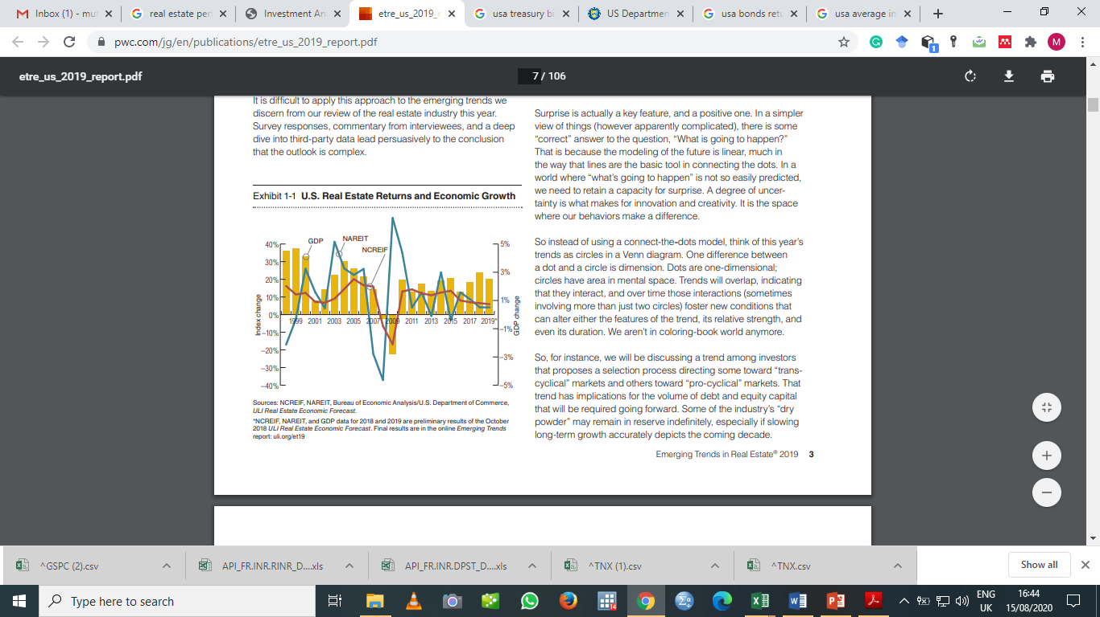
Source: PWC (2019)

Return on Treasury bonds
Previous 1 year
Date | Price | Return (%)
01/09/2019 | 1.675
01/10/2019 | 1.691 | 1%
01/11/2019 | 1.776 | 5%
01/12/2019 | 1.919 | 8%
01/01/2020 | 1.52 | -21%
01/02/2020 | 1.127 | -26%
01/03/2020 | 0.698 | -38%
01/04/2020 | 0.622 | -11%
01/05/2020 | 0.648 | 4%
01/06/2020 | 0.653 | 1%
01/07/2020 | 0.536 | -18%
01/08/2020 | 0.709 | 32%
14/08/2020 | 0.709 | 0%

Previous 5 and 10 years
Date | Close | Return (%)
01/08/2009 | 3.401
01/12/2009 | 3.843 | 13%
01/12/2010 | 3.305 | -14%
01/12/2011 | 1.871 | -43%
01/12/2012 | 1.756 | -6%
01/12/2013 | 3.026 | 72%
01/12/2014 | 2.17 | -28%
01/12/2015 | 2.269 | 5%
01/12/2016 | 2.479 | 9%
01/12/2017 | 2.405 | -3%
01/12/2018 | 2.686 | 12%
01/12/2019 | 1.919 | -29%
14/08/2020 | 0.709 | -63%

Return on Treasury bills
Previous 1 year
Date | Price | Return (%)
01/09/2019 | 1.77
01/10/2019 | 1.498 | -15%
01/11/2019 | 1.54 | 3%
01/12/2019 | 1.505 | -2%
01/01/2020 | 1.51 | 0%
01/02/2020 | 1.23 | -19%
01/03/2020 | 0.03 | -98%
01/04/2020 | 0.09 | 200%
01/05/2020 | 0.128 | 42%
01/06/2020 | 0.135 | 5%
01/07/2020 | 0.083 | -39%
01/08/2020 | 0.088 | 6%
14/08/2020 | 0.088 | 0%

Previous 5 and 10 years
Date | Price | Return
01/09/2009 | 0.115
01/12/2009 | 0.05 | -57%
01/12/2010 | 0.115 | 130%
01/12/2011 | 0.005 | -96%
01/12/2012 | 0.035 | 600%
01/12/2013 | 0.063 | 80%
01/12/2014 | 0.037 | -41%
01/12/2015 | 0.148 | 300%
01/12/2016 | 0.48 | 224%
01/12/2017 | 1.355 | 182%
01/12/2018 | 2.3 | 70%
01/12/2019 | 1.505 | -35%
14/08/2020 | 0.088 | -94%

Return on investment in interest earning savings account
Year | Interest rates
2009 | 2.47
2010 | 2.06
2011 | 1.14
2012 | 1.31
2013 | 1.47
2014 | 1.33
2015 | 2.17
2016 | 2.39
2017 | 2.15
2018 | 2.49
2019 | 3.48

Return on investment in stocks
Previous 1 year
Date | S&P 500
01/09/2019 | 2,976.74
01/10/2019 | 3,037.56
01/11/2019 | 3,140.98
01/12/2019 | 3,230.78
01/01/2020 | 3,225.52
01/02/2020 | 2,954.22
01/03/2020 | 2,584.59
01/04/2020 | 2,912.43
01/05/2020 | 3,044.31
01/06/2020 | 3,100.29
01/07/2020 | 3,271.12
01/08/2020 | 3,372.85
14/08/2020 | 3,372.85

Previous 5 and 10 years
Date | S&P 500
01/09/2009 | 1,057.08
01/12/2009 | 1,115.10
01/12/2010 | 1,257.64
01/12/2011 | 1,257.60
01/12/2012 | 1,426.19
01/12/2013 | 1,848.36
01/12/2014 | 2,058.90
01/12/2015 | 2,043.94
01/12/2016 | 2,238.83
01/12/2017 | 2,673.61
01/12/2018 | 2,506.85
01/12/2019 | 3,230.78
14/08/2020 | 3,372.85

Investment proportions
Since all of the investment assets promise almost the same pattern of return and none seems to have distinguishably superior performance than the rest, I would invest in the five assets in equal proportions and keep monitoring the investment. I would therefore invest 20% of investment funds in each of the five assets.
- Using the tool instruments contained within the Lesson Two reading, develop your financial goals using the chart on page four. List the top five financial goals for what you want to save or invest for, along with a corresponding date for each. Reflect on any obstacle that may prevent you from achieving your personal financial goals. Share examples to help illustrate your plans. (the reading can be found by searching savings and investing pdf its on the sec.gov)
Chart for financial goals
What I want to invest for | By when
Buying a home | Summer 2025
Starting a children home | April 2021
Masters degree funds | September 2023
Buying a car | January 2023
Investing for retirement | May 2055

Expected obstacles that can prevent achievement of financial goals
- Adverse change in interest rates
Example: An decrease in interest rates may mean my current savings will grow at a slower rate and will not have accumulated to the desired amount by the time I want to meet a certain financial goal.
- Significant increase in market prices
Example: Increase in the market prices of homes will make my accumulated amounts not able to meet the financial goal, which may prevent or delay the achievement of the goal.
- Deterioration in political situation in South Sudan where I want to start the children home
Example: It would be hard for a foreigner to establish any organization in a foreign land with unstable political situation.
- Unexpected change in my current stream of income
Example: a decrease in my stream of income will result to little savings than anticipated and as a result may not accumulate to the desired amounts to meet the financial goals.
- Any change in my preference for cars
Example: If I change my preference for cars and need a more expensive car, I may not achieve the goal at the desired time. Changing preference to public means of transport may mean abandoning the goal altogether.

- W3.Part 1 – Congratulations, you just hit the lottery jackpot for one million dollars. You now have an option to receive $50,000 each year for 20 consecutive years, or you can receive $700,000 upfront on day one. Ignoring tax implications, what would you select, and why? How does the current and future value of money enter into your calculations? How does inflation, and future cost of items factor into your calculations? Please share your calculations with the class, along with your arguments and evidence.
Pv of 50,000 annual payments for 20 years, assuming interest rate is 3%.
$$Pv=A×PVIFA 3\%, 20 Years$$
$$Pv=50,000×14.8775$$
$$Pv=\$743,875$$
I would opt to receive $50,000 yearly for 20 years as that has a higher present value of $743,875 compared to an upfront payment of $700,000
Present value of money enters into the calculations as money has a different value depending on the period. This is because of inflation, investment potential of money at hand among other factors.
Inflation and future cost of items is also a key consideration as it relates directly to the value of money. High inflation will make money to lose value hence a preference to the certain amount now as opposed to future payments, which may reduce in value and be able to purchase just a fraction of what could be purchased today.

W3.Part 2 – You have $10,000 to invest. Your Grandmother, who doesn’t trust banks, has advised you to put the money under your mattress to save for the future. Conversely, your Mother suggests you open a savings account at a bank. In your town, the banks are currently offering 3% interest. One bank (Bank A) compounds the interests each quarter (March 31, June 30, September 30, and December 31). The other bank (Bank B) compounds the interest on an annual basis (December 31). Assuming you would save your money for the next 10 years, what would your balance be in Bank A and in Bank B? Please describe your calculations within your response.
Compound interest ensures that interest is earned on interest for previous periods.
Bank A balance after 10 years
$$FV=PV{\left(1+r\right)}^{t}$$
$$FV=10,000{\left(1+0.0075\right)}^{40}$$
$$FV=10,000{\left(1.0075\right)}^{40}$$
$$FV=10,000×1.3483$$
$$FV=\$13,483$$
Bank B balance after 10 years
$$FV=PV{\left(1+r\right)}^{t}$$
$$FV=10,000{\left(1+0.03\right)}^{10}$$
$$FV=10,000{\left(1.03\right)}^{10}$$
$$FV=10,000×1.3439$$
$$FV=\$13,439$$
Bank A has a better balance after 10 years due to more compounding times in a year. This ensures that interest earns interest more times compared to bank B.

- Access the Investment Risk Tolerance Quiz (Lesson Four Quiz) assignment. Answer the 13 questions as honestly as you can, and as they apply to your personal feelings toward money, gambles, certainties, thrills, and comfort. Tally your score using the scoring guide at the end of the Investment Risk Tolerance Quiz. Share your results with the class. Are you a conservative investor, moderate, or aggressive? Additionally, state whether you were surprised or expected the results you identified. Provide life examples of times when your actions resembled your Risk Tolerance Quiz findings (attached)

I’m a moderate investor with a score of 22 out of 47.
I was not surprised because I see myself as an investor who does not fear risking but at the same time does not risk too much.
I once participated in a game where I was to predict the team, which will win in a virtual game. I staked a small amount of money and continued winning until the amount of money was 12 times the amount I had staked. I withdrew 10 times the amount I staked, had lunch with my friends and continued staking the balance. As I expected, I lost the amount I did not withdraw but luckily, I had withdrawn some “profit”

- Many financial advisors would suggest investors never place all of their “eggs into a single basket”. However, some others (such as Mark Cuban and Warren Buffett) believe diversification can be a burden on the potential of portfolio growth, by placing unnecessary limits on gains. Where do you stand on this debate? How might the everyday investor (as compared to the aforementioned billionaires) limit their risk to the potential highs and lows/volatility of the financial markets? Is portfolio diversification necessary? How often should the investor review his or her holdings, and how often should the investor rebalance their holdings? Please share examples in support of your response.
Diversification is better than “putting all eggs in one basket”
Everyday investors can limit their risk by diversifying across industries or stocks. This ensures that risks which affect a certain industry or stock does not affect all invested funds as would be the case if they were all invested in just one industry or stock
Portfolio diversification is necessary as it reduces risks associated with an investment. It reduces the chances that all stocks can be affected negatively at the same time while promising better and more predictable returns.
An investor should review and rebalance their holdings as frequent as they get any relevant news. The news can be like resignations of key people in companies, emergence of competitors in the industry or findings that a company has been acting unethically. This is because other investors will sell or buy any particular stock depending on whether the news are “good” or “bad”.
6. One of the major principles of investing is to “buy low and sell high”. Real estate investments can complement one’s portfolio, depending on many simultaneous factors. Some investors purchase properties to rent. Others purchase properties to repair, improve upon, and then to sell for a profit. Yet others may acquire real estate to reside and enjoy. Within the context of investing, please describe how each of the following factors may positively or negatively impact one’s real estate holdings within the investment portfolio:
- Change in real estate tax rates (county, municipal, and school)
Change in real estate tax rates is negatively related to the performance of real estate’s portfolio. Where tax rates are increased on the real estates, other investments become more attractive and hence the performance declines in the sector. Where the tax rates are lowered, it means there will be more returns and the sector flourishes.
- Factory or plant openings or closings within the area
Factory openings have a positive influence on real estate business as this increases demand for property to accommodate the employees and other businesses around the factory. On the contrally, closing of plants and factories may have a negative impact on real estate performance as it results to lesser demand for the real estate services.
- Public school system serving the neighborhood
Public schools are among the support service facilities that boost the real estate performance as people will prefer to incur the least cost taking their kids to school hence availability of public school positively affects the real estates.
- The attention to neighbors and property upkeep
Property upkeep has a positive impact on the real estate in that where full attention to the neighborhood has been provided, people will feel more comfortable residing in the place hence increasing demand for the real estates. On the contrally, poorly managed environment is unpleasant and may not attract more residents to the place leading to poor performance.
- The economic health of the community
The economic health of a community has a positive impact on the real estate performance because when people are well off, they are able to meet their basic needs among which shelter is part of it and this improves the perfo0rmance of real estates.
- Violence or safety records of the neighborhood
Violence has a negative influence on the performance of the real estate business as people will not be willing to risk their lives if they can afford a safer environment. On the other hand, safety has a positive influence on the real estate performance as people will even be willing to pay more for their safety.
- Overall supply and demand for properties within the neighborhood
The supply of properties has a negative impact in the performance of the real estates in that when there is high supply, prices of the properties tend to fall hence reduced performance of properties. On the other side, demand has a positive influence as when the demand is high, prices tend to rise hence increasing the performance of real estate properties.
- The mechanical aptitude of the property owner to repair and maintain such property
The mechanical aptitude of the owner to maintain the property has a positive influence on the performance of the real estates in that people will be willing to pay even more for the same property if it is properly maintained than those which are poorly maintained.
7. Over a seven-day period, write down every penny that you spend, and what you buying. Include in your analysis, the monthly expenses you identified earlier in the course. Examine your analysis. What patterns do you see? What is your latte factor? That is, what might you be able to sacrifice, in favor of plowing more money into your savings? Now that you have identified areas of savings, how might you be able to make the savings automatic? Does your employer have a 401K savings plan? Or, instead of asking for new clothing at holidays or birthdays, might you ask your Grandparents for gifts such as a savings bond, or a silver or gold coin? Share examples in support of your response.
Day | Item | Amount $ |  | Day | Item | Amount $
1 | Breakfast | 10 |  | 5 | Breakfast | 7
 | Lunch | 15 |  |  | Lunch | 19
 | Evening drink | 30 |  |  | House electronics | 28
 | Dinner | 20 |  |  | Saving account | 150
 |  |  |  |  | Dinner | 29
2 | Breakfast | 9
 | Lunch | 17 |  | 6 | Breakfast | 8
 | Clothes | 25 |  |  | Lunch | 20
 | Shares | 100 |  |  | Bottled water | 50
 | Dinner | 18 |  |  | Dinner | 18
3 | Breakfast | 12 |  | 7 | Breakfast | 12
 | Lunch | 10 |  |  | Lunch | 15
 | Utilities | 20 |  |  | Refreshments | 25
 | Saving account | 200 |  |  | Night out expenses | 20
 | Dinner | 19 |  |  | Dinner | 14
4 | Breakfast | 10 |  |  | Total | 1,045
 | Lunch | 16
 | Loan repayment | 10
 | Rent | 65
 | Dinner | 24
The pattern shows that there are some repeated expenses, which are incurred on a daily basis, which are of low value while the monthly expenses are few but with high value.
The latte factor in my case will be one of the meals between breakfast, lunch and dinner, which can be substituted with a mare snack to create saving money. In my case would consider substituting lunch for a snack, which could create approximately $100 for saving in addition to the investment and saving funds of $450. To make this saving automatic, I would request my employer to withhold the deduction before monthly pay and submit it to the saving scheme together with other mandatory deductions and contribution made. As the employer has a 401(k) saving plan, this savings shall be added to the plan. In order to boost my investments towards my retirement plan, I will be making request to my friends and family members to offer shares in stocks or bonds as gifts on specific occasions. For instance, during my previous birthday, I received bonds and shares worth $280 which as a way of remembering I plan to roll them until my retirement. On top of this, we have formed a welfare association with my colleagues at work aimed at purchasing bonds in lump on a monthly basis and distributing them at year-end among members as a way of boosting individuals saving plan.
8. At what age would you recommend starting to plan for retirement? Do you feel comfortable developing your own retirement plan without the professional assistance of a financial advisor/planner? Describe the pros and cons of using a financial planner in developing a retirement plan. Please support your argument with facts, research, and evidence.
I would prefer to start my retirement plan at my 30’s. This is because at this point I will expect to be having a tight schedule of developing my life and family but training on saving for retirement will be ideal to meet the retirement number comfortably before the age. On my side, I will feel comfortable developing my retirement plan in the aid of a professional assistant. The main benefit of doing it myself is because even I will save the cost to pay the professional and get more exposure to financial planning. With so many options available, one may end up missing the point on this critical process, which matters in life but at the same time remains to be a complex process like in selection of 401(k) plan, choosing your IRAs or even rolling over the 401(k). On the other hand, using a professional in beneficial as it will save my time in planning, stress in planning and follow up but more important getting the plan right which is long lasting as proposed by Dave Ramsey. Wade also state that such advisory will give employees knowledge on the benefit of saving and provide the saving option that will maximize on the retirement benefits for holders.

References (For question 1)
https://finance.yahoo.com/
https://data.worldbank.org/indicator/FR.INR.RINR?locations=US

